Dear Friends of Saint Charles Caritas,

There is nothing more rewarding and fulfilling than to serve God. Jesus Christ, thank you for your love and protection for the children and us.

February 6, 2021, Saturday was Feed the Children #32. 104 children were served soup and 8 volunteers. Before serving, a thank you prayers were said by Sopia. For the volunteers, teacher Norly Gane cooked sausages with eggs sauteed with onions, tomatoes and garlic.Thank you to all of you who make this mission possible every week!

Please see a collage of pictures below, done by Mr. Alex Rullan.
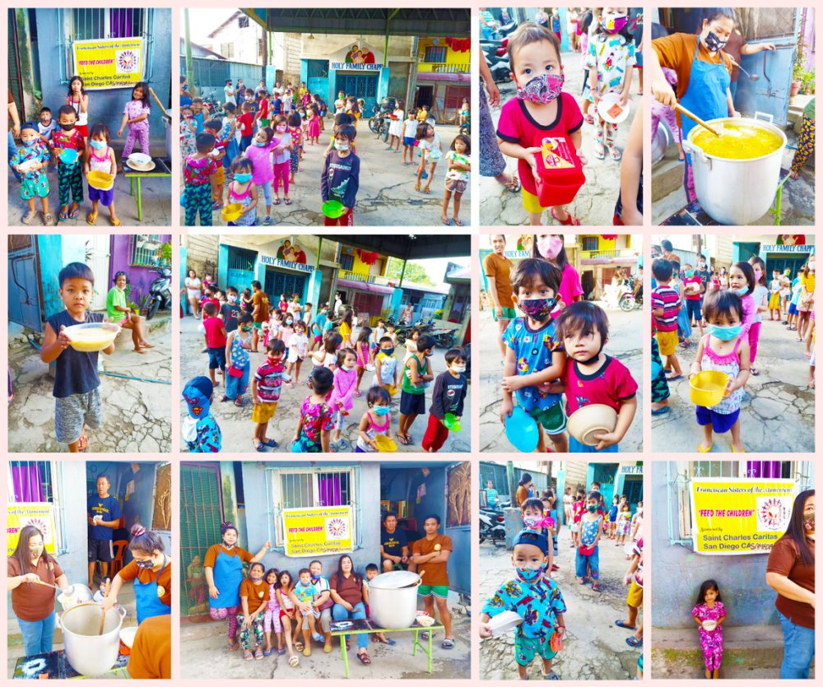
February 7, 2021, Sunday was the Teach the Children How to Pray the Rosary week 17. Thank you teachers: Regina Tesorero and Analiza Yauna. 60 children attended and 9 volunteers. Champorado was served to the children. Mrs. Norly Gane cooked pasta for the volunteers. The opening prayer was led by teacher Joedelyn thanking God for our health, family, protection, healing of the sick and etc. Teacher Michelle, took the pictures and video. Currently, we had 5 teachers volunteers.
Recap: *** Reviewed what was the lessons last week. *** Q & A, favorite by the children and the rewards were all 15 snack bars. *** Numbers of children who can memorized 5 prayers: 15 Apostles Creed, 5 the Our Father, 40 Hail Mary, 60 Glory Be to the Father and 2 Hail Holy Queen. The youngest who attended was 2 years old and the oldest, 13 years old.

All the children and volunteers got a face shields donated by Atty. Jesse Remulla Grepo, Provincial Legal Officer of Cavite. Face shields were dropped off by Cocoy, his cousin. Thank you so much!

- We will have a new program called Baptism for Children (for the poorest of the poor children) in Phase 1 to 5, Paliparan. Many children are not baptized yet. Currently, teachers Regina and Analiza will talk to the priest of Christ the King Church. I will let you know the requirements of Baptism and how many children are going to be baptized. Please see below a collage of pictures.

- We are also going to continue the Rosary Evangelization by providing set of rosaries to the Hospitaller Sacred Heart of Jesus, Quezon City and these will be sent soon for distribution to the poor families in different places and islands.
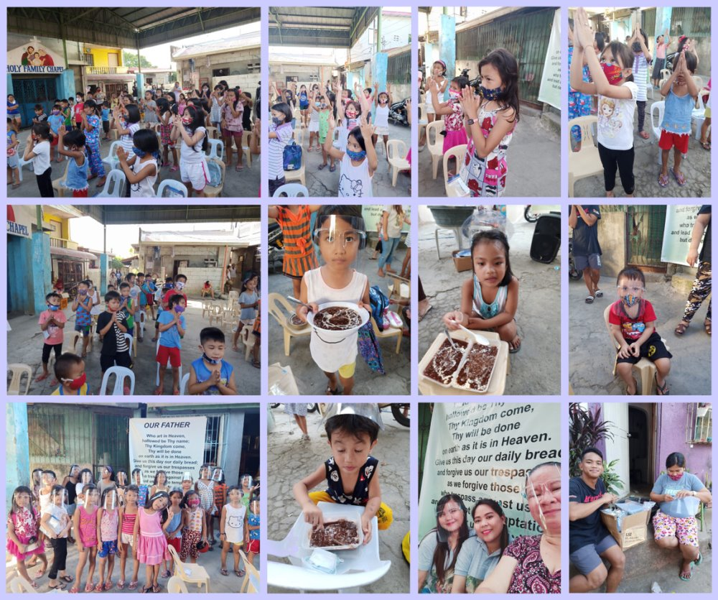
February 13, Saturday was Feed the Children #33 in another squatter area. Every week, the Feed the Children is in different squatter areas. 105 children came and although it was pouring rain, the children showed up with their tickets and some parents came in lieu of their children.All were soaking wet, but it did not stop the children from getting the egg noodle soup with the volunteers. Before serving the soup,(children) Sopia, James, Tyron and Darrel leading the thank you prayers mentioning the Franciscan Sisters of the Atonement and Saint Charles Caritas.Thank you to Teacher Norly and volunteers. 9 volunteers helped and Mrs. Norly cooked sauteed eggs with sausages, onions and tomatoes for the volunteers meal.

Please see a collage done by Mr. Alex Rullan. Thank you Brother Alex.
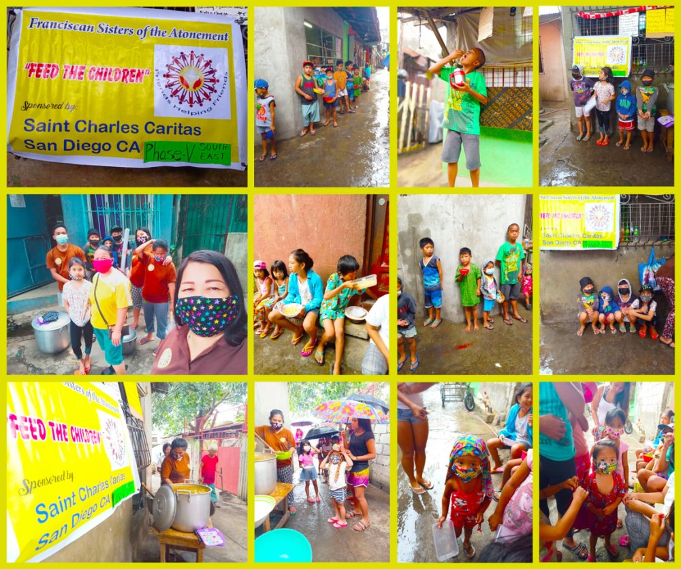
February 14, Sunday was the Teach the Children How to Pray the Rosary week 18. 43 children attended the class (the youngest was 2 years old to 13 years of age) and 8 volunteers. Thank you to teachers Regine Tesorero and Analiza Yauna and teacher Norlina Gane for cooking the spaghetti and soup for the children. Meals served after the class and prayers were said.
Recap: Opening prayers: Thanking God for His blessings, food, health, Saint Charles Caritas donors, parents,and Jonvic Remulla, governor of Cavite to soon approve the request to pave and solar lights for the Samada Half Court. Also, a video thanking Atty Jesse Remulla Grepo for the face shields which the children were using. *** The accumulated count who can now memorized the prayers: Apostles Creed, 16 children; Our Father, 46; Hail Mary 42, Glory Be, 62 and Hail Holy Queen, 3. ***The two teachers emphasized the importance of Jesus Christ and prayers. "God is love" and the Valentines Day. Also, the 2 teachers explaining that to pray the Rosary not only Sundays but everyday with their families; to be sincere in praying and the reflection of Jesus Christ is love. *** The teachers pointed out the picture of Baby Jesus and Blessed Mother Mary on the tarpaulin and asking for Baby Jesus and Blessed Mother Mary's help. *** The children shared their prayer intentions such as going back to school because he had a hard time with module classes; another kid prayed for that many people will survive this pandemic; another kid that his sister will come back home because the family did not see her for a long time,.and many people will come back to work and etc. *** The assignment is to pray the 5 decades of the rosary .daily.*** According to the teachers, the children were super happy!

Please see attached video of a 2 year old boy singing the Glory Be to the Father. I'm hoping that I can send to you the 3 prayers in songs sang by the children.Mr. Alex is going to figure it out how to make the size of the video smaller. My computer is not allowing for me to send a 25.64 mb.Please see a collage below.
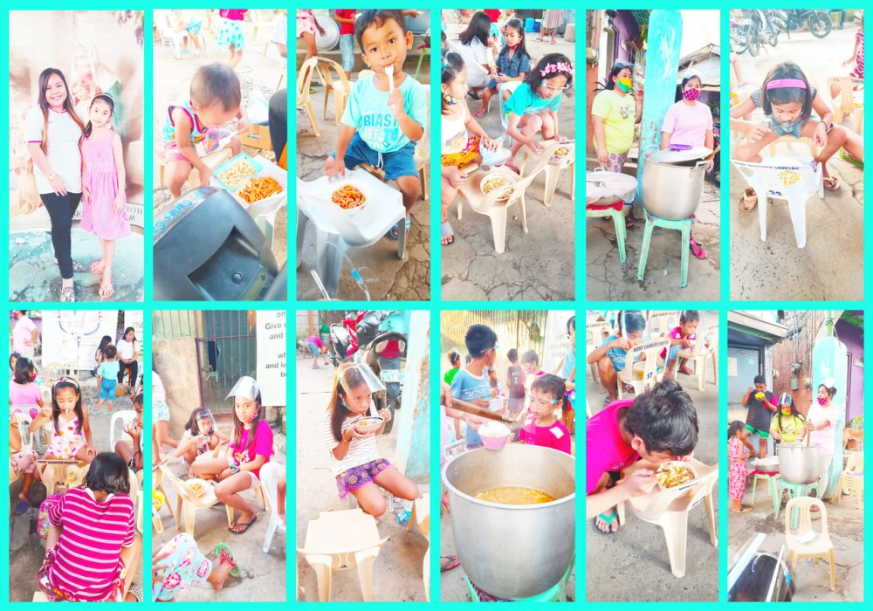
Sincerely,
Merlyn Baker
Saint Charles Caritas
Imperial Beach/South San Diego
990 Saturn Blvd.
San Diego, CA 92154
tel# (619) 428-0199
SaintFrancis2001@aol.com
http://saintcharles.org/st-charles-caritas/

